UNESCO Agenda 1: **Access to education and health care in conflict and post conflict zones**

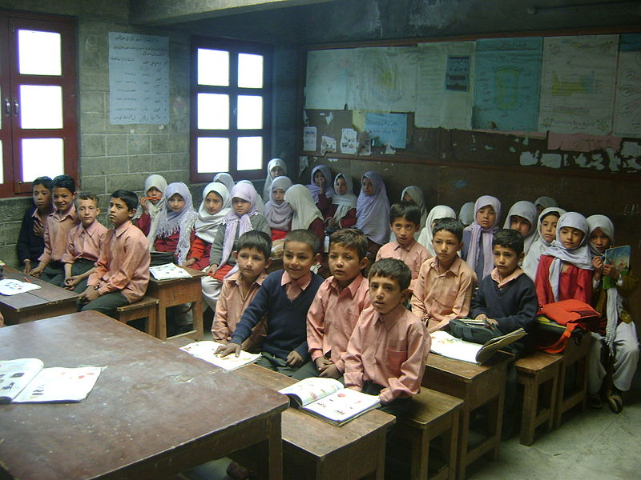

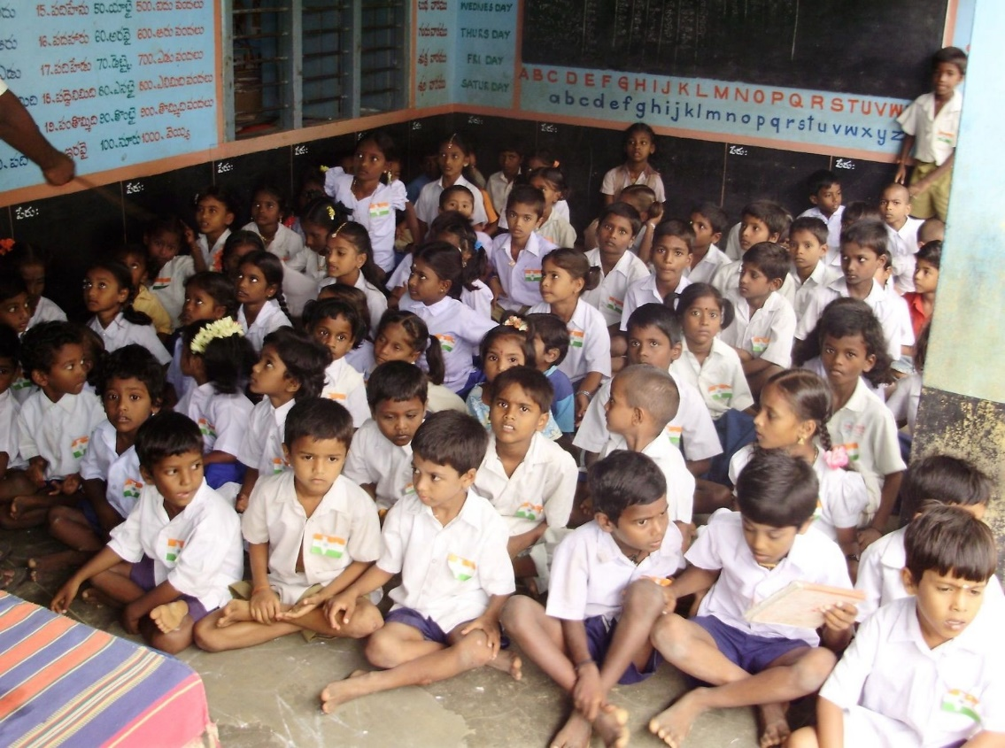

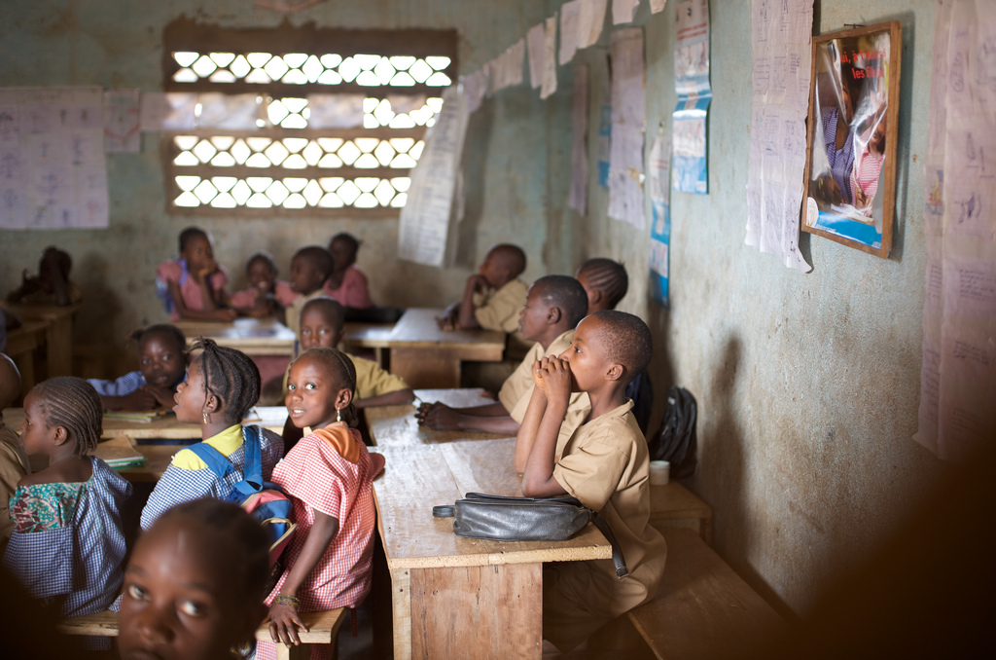

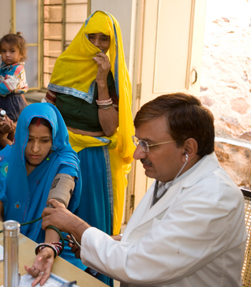

UNESCO Agenda 2 : **To suggest measures for protection of cultural heritage in the middle east**

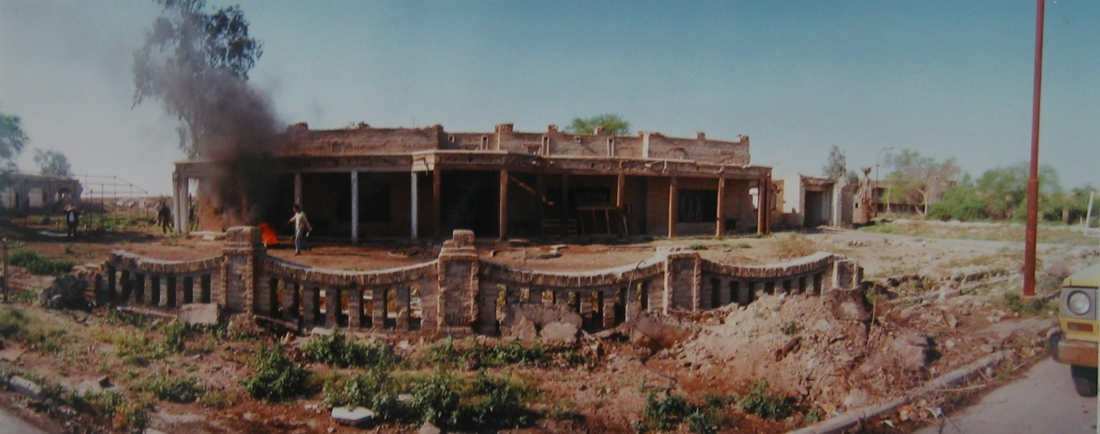

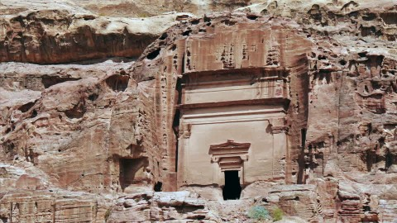

HRC Agenda 1: **To suggest measure for Protection of freedom of expression in the middle east with special emphasis on atheists/unaffiliated**

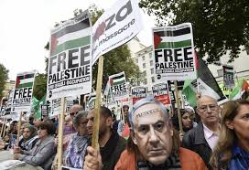

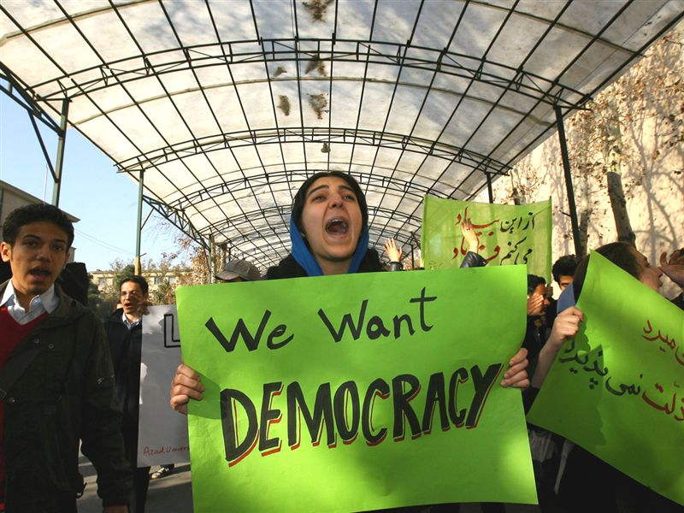

HRC Agenda 2: **To discuss the promotion of Gender Equality in Education**





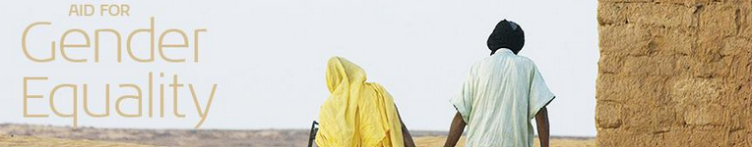

UNCOPUOS Agenda 1and 2: **To discuss the need for improvement in the International Legislation on the Commercial Uses of Outer Space**



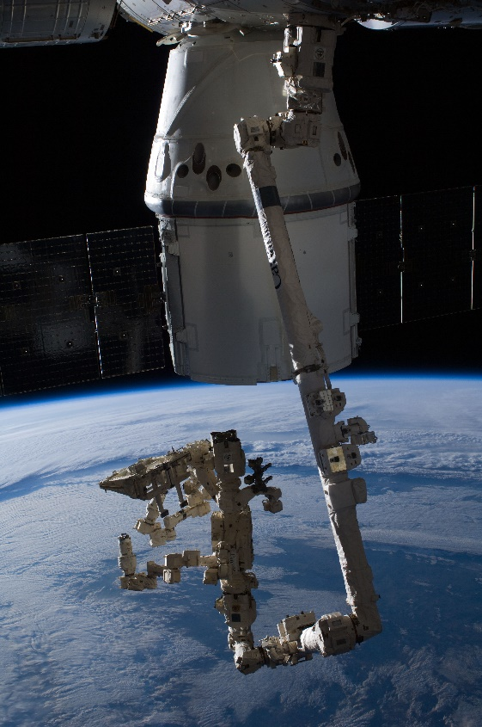



**UNCOPUOS AGENDA 2 :To discuss the the threat of usage of Nuclear Power Sources in Outer Space**

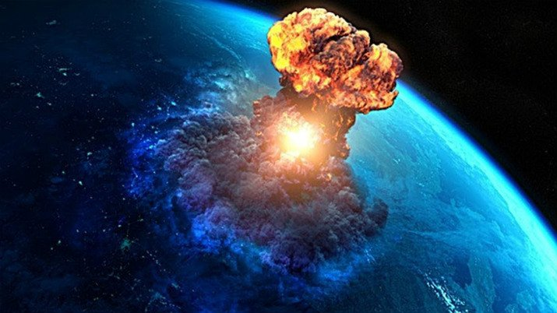

HUNSC Agenda : **The nationalisation of Suez Canal**

